**1. Write a program to demonstrate the following:**

(a)Different numeric data types

(b)To perform different arithmetic operations

**Aim :** The aim of this program is find the different numeric data types in python and also to perform different arithmetic operations.

**Description:** Python supports several numeric data types, including integers, floating-point numbers, and complex numbers. **This** program demonstrates the different numeric data types and performs various arithmetic operations.

**Numeric Data types:**

**Integers**

Integers are whole numbers, positive or negative, without decimals, of unlimited length.

Example: 5, -10, 150

**Floating-Point Numbers**

Floating-point numbers are real numbers with a floating point representation. They are specified with a decimal point.

Example: 5.0, -10.5, 150.0

**Complex Numbers**

Complex numbers are numbers with a real and imaginary component represented as a + bj, where a is the real part and b is the imaginary part.

Example: 3 + 4j, -5 + 2j

**Arithmetic Operations**

1. Addition :

Example : 5 + 6

(2)Subtraction : Subtracts one number from another.

Example : 10 - 3

(3)Multiplication : Multiplies two numbers together.

Example : 3 * 2

(4) Division : Divides one number by another.

Example : 10 / 5

(5)Modulus : Returns the remainder of a division operation.

Example : 5 % 6

**Program Implementation:**

#Program to print different numeric data typesin python and to perform arithmetic operations

a = 10

b = 15.5

c = 5 + 4j

print("** Different Numeric data types are **")

print(a,"is Type of",type(a))

print(b,"is Type of",type(b))

print(c,"is Type of",type(c))

print("\n** Arithmetic Operations **")

num1 = int(input("Enter num1 value : "))

num2 = int(input("Enter num2 value : "))

print("Addition : num1 + num2 = ",num1 + num2)

print("Subtraction : num1 - num2 = ",num1 - num2)

print("Multiplication : num1 * num2 = ",num1 * num2)

print("Division : num1 / num2 = ",num1 / num2)

print("Modulus : num1 % num2 = ",num1 % num2)

**Result:**

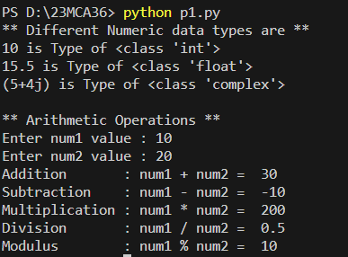

**2. Write a program to find a factorial of a number using recursion**

**Aim :** The aim of these program is to find factorial of number using recursion function

**Description:** The factorial of a number is the product of all positive integers up to that number.

For example, the factorial of 5 is 1*2*3*4*5 = 120.

**Recursion** is a programming technique where a function calls itself to solve a problem by breaking it down into smaller sub-problems. In this program, we use recursion to find the factorial of a number.

In this program, we used recursion to find the factorial of a number. The factorial function takes an integer n as input and returns its factorial. The base case is when n is 0, in which case the function returns 1. Otherwise, the function calls itself with the argument n-1 and multiplies the result by n.

**Program Implementation:**

def recursion_fact(n):

if n == 1:

return n

else:

return n * recursion_fact(n-1)

num = int(input("Enter a num value : "))

if(num < 0):

print(f"Factorial of a given number {num} is not possible")

elif(num == 0):

print("Factorial of 0 is 1")

else:

print(f"Factorial of a given number {num} is = {recursion_fact(num)} ")

**Result:**

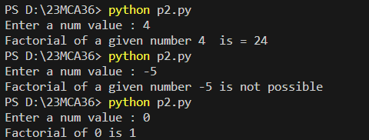

**3. Write a python program to check whether a given number is Armstrong number or not**

**Aim:** The aim of this program is to find whether a given input number id Armstrong number or not

**Description:** An Armstrong number in a given number base b is a number that is the sum of its own digits each raised to the power of the number of digits. To put it simply, if I have a 3-digit number then each of the digits is raised to the power of three and added to obtain a number. If the number obtained equals the original number then, we call that Armstrong number. The unique property related to the Armstrong numbers is that it can belong to any base in the number system.

For example, in the decimal number system, 153 is an Armstrong number.

1^3+5^3+3^3=153

**Code Implementation:**

num = int(input("Enter the num value : "))

sum = 0

temp = num

while temp > 0:

digit = temp % 10

sum += digit ** 3

temp //= 10

if num == sum:

print(num,"is a armstrong number")

else:

print(num,"is not armstrong number")

**Output:**

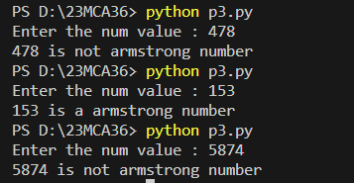

**4. Write a program to create classes and objects**

**Aim:** The aim of this program is to create class and accessing methods and variables by creating class objects.

**Description:** Python is an object oriented programming language almost everything in Python is an object, with its properties and methods.

A Class is like an object constructor, or a "blueprint" for creating objects .To create a class we class keyword

E.g.: class Student:

Roll no = 11

An object is a real time entity.

E.g. s1 = Student ()

In this program we going to create a Student class and to print his/her name, roll no, 5 subject marks and to calculate total and average and display the result

**Code Implementation:**

class Student:

def s_info(self):

self.name = input("Enter a Student name : ")

self.reg_no = int(input("Enter reg_no : "))

self.sem = int(input("Enter semester : "))

self.section = input("Enter a section : ")

def cal(self):

self.m1 = int(input("Enter maths marks : "))

self.m2 = int(input("Enter stat marks : "))

self.m3 = int(input("Enter java marks : "))

self.m4 = int(input("Enter python marks : "))

self.total = self.m1+self.m2+self.m3+self.m4

self.res = self.total/4

#displaying student information

def display(self):

self.s_info()

self.cal()

print("** STUDENT INFORMATION **")

print("Name = ",self.name)

print("Reg_No = ",self.reg_no)

print("Semester = ",self.sem)

print("Section = ",self.section)

print(" Marks Scored in each subject :")

print("Maths = ",self.m1)

print("Stat = ",self.m2)

print("Java = ",self.m3)

print("Python = ",self.m4)

print("Total marks = ",self.total)

print("Percentage = ",self.res)

if self.res >= 85:

print("Grade : A")

elif self.res >= 75:

print("Grade :B")

elif self.res >= 65:

print("Grade :C")

elif self.res >= 55:

print("Grade :D")

elif self.res >= 45:

print("Grade :E")

else:

print("Grade :Failed")

#creating objects

s1 = Student()

s2 = Student()

s1.display()

s2.display()

**Result:**

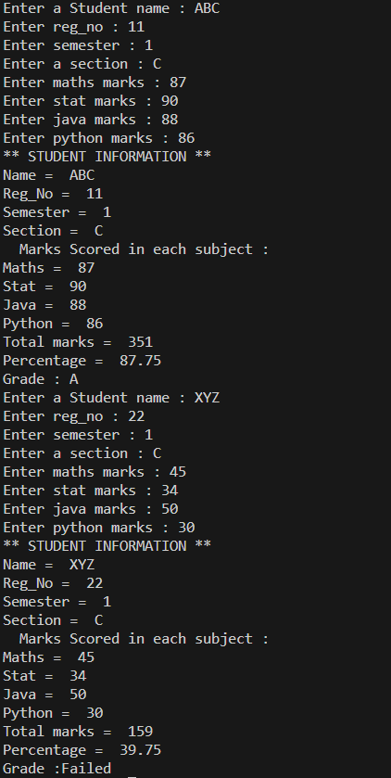

5. Write a program to reverse a string word by word

Aim: The aim of this program is to reverse a given string word by word

Description:

**6.Write a python program to create append and remove elements from lists.**

**Aim:** To create a python program and perform list operations like append and remove elements from lists.

Description: In python, a list is a built-in data structure that allows us to store and manage a collection of item lists. Lists are one of the most versatile and commonly used data structure in python and are used for a wide range of task such as storing, collection of data, implementing data structures, and processing data.

In order to create, append and remove elements from lists in Python, we first determine the action the user wants to perform by accepting the choice from the user. Based on the user choice, we create a list by List_name = [] and append the element into the list using append () and the removal of into elements from the list is done through remove() and display the updated list using print().

**Code:**

def create_list():

global my_list

my_list = []

print("New empty list created.")

#return my_list

def append_to_list(element):

my_list.append(element)

print(f'Appended {element} to the list.')

def remove_from_list(element):

try:

my_list.remove(element)

print(f'Removed {element} from the list')

except ValueError:

print(f'{element} not found in list')

def display_list():

print("Current List",my_list)

while True:

print("\nChoose an action")

print("1.Create a new list")

print("2.Append an element to the list")

print("3.Remove an element from the list")

print("4.Display the current list")

print("5.Exit")

choice = input("Enter your choice(1/2/3/4/5) :")

if choice == '1':

create_list()

elif choice =='2':

element = input("Eneter an element to append : ")

append_to_list(element)

elif choice == '3':

element = input("Enter an element to remove :")

remove_from_list(element)

elif choice == '4':

display_list()

elif choice == '5':

break

else:

print("Invalid choice. Please try again")

**Output:**

PS D:\23MCA36> python p6.py

Choose an action

1.Create a new list

2.Append an element to the list

3.Remove an element from the list

4.Display the current list

5.Exit

Enter your choice(1/2/3/4/5) :1

New empty list created.

Choose an action

1.Create a new list

2.Append an element to the list

3.Remove an element from the list

4.Display the current list

5.Exit

Enter your choice(1/2/3/4/5) :4

Current List []

Choose an action

1.Create a new list

2.Append an element to the list

3.Remove an element from the list

4.Display the current list

5.Exit

Enter your choice(1/2/3/4/5) :2

Eneter an element to append : 10

Appended 10 to the list.

Choose an action

1.Create a new list

2.Append an element to the list

3.Remove an element from the list

4.Display the current list

5.Exit

Enter your choice(1/2/3/4/5) :2

Eneter an element to append : 20

Appended 20 to the list.

Choose an action

1.Create a new list

2.Append an element to the list

3.Remove an element from the list

4.Display the current list

5.Exit

Enter your choice(1/2/3/4/5) :2

Eneter an element to append : 30

Appended 30 to the list.

Choose an action

1.Create a new list

2.Append an element to the list

3.Remove an element from the list

4.Display the current list

5.Exit

Enter your choice(1/2/3/4/5) :2

Eneter an element to append : 40

Appended 40 to the list.

Choose an action

1.Create a new list

2.Append an element to the list

3.Remove an element from the list

4.Display the current list

5.Exit

Enter your choice(1/2/3/4/5) :4

Current List ['10', '20', '30', '40']

Choose an action

1.Create a new list

2.Append an element to the list

3.Remove an element from the list

4.Display the current list

5.Exit

Enter your choice(1/2/3/4/5) :3

Enter an element to remove :20

Removed 20 from the list

Choose an action

1.Create a new list

2.Append an element to the list

3.Remove an element from the list

4.Display the current list

5.Exit

Enter your choice(1/2/3/4/5) :4

Current List ['10', '30', '40']

Choose an action

1.Create a new list

2.Append an element to the list

3.Remove an element from the list

4.Display the current list

5.Exit

Enter your choice(1/2/3/4/5) :5

**7. Write a python program to demonstrate the working of tuple.**

**Aim:** To generate a python program to demonstrate the working of tuples.

Description: In python, a ‘tuple’ is an ordered immutable collection of elements unlike lists, which are mutable and use square brackets ‘[]’. Tuples use parentheses ‘()’. Tuples are practically useful that when we want to ensure that the data remains unchanged and is treated as a single unit.

For demonstrating the working tuples in python initially we determine the action user wants to perform that is: add element to the tuple, access element in the tuple, remove element from the tuple and display the tuple. Based on user choice, we create the tuple by tuple_name = (). We add items to the tuple by tuple_name= tuple_name+(element to be added).And since tuples, are immutable we remove elements by converting the tuple to list by list(tuple_name) and again convert the list back to tuple by tuple(list_name).

**Code:**

def create_tuple():

my_tuple=()

print("Empty tuple created.")

return my_tuple

def add_to_tuple(my_tuple,element):

my_tuple+=(element,)

print(f"Added '{element}' to the tuple.")

return my_tuple

def access_tuple(my_tuple,index):

if 0<=index<len(my_tuple):

element=my_tuple[index]

print(f"Element at index {index}:{element}")

else:

print("Invalid index.")

def remove_from_tuple(my_tuple,element):

if element in my_tuple:

my_list=list(my_tuple)

my_list.remove(element)

my_tuple=tuple(my_list)

print(f"Removed '{element}' from the tuple.")

return my_tuple

else:

print(f"'{element}' not found in the tuple.")

def display_tuple(my_tuple):

print("Current Tuple:",my_tuple)

my_tuple=create_tuple()

while True:

print("\n Choose an action:")

print("1.Add an element to the tuple")

print("2.Access an element in the tuple")

print("3.Remove an element from the tuple")

print("4.Display the current tuple")

print("5.Exit")

choice=input("enter your choice (1/2/3/4/5):")

if choice=='1':

element=input("Enter a element to add:")

my_tuple=add_to_tuple(my_tuple,element)

elif choice=='2':

index=int(input("Enter the index to access:"))

access_tuple(my_tuple,index)

elif choice=='3':

element=input("Enter the element to be remove:")

my_tuple=remove_from_tuple(my_tuple,element)

elif choice=='4':

display_tuple(my_tuple)

elif choice=='5':

break

else:

print("Invalid choice.Please try again:")

**Output:**

PS D:\23MCA36> python p7.py

Empty tuple is created

Choose an action :

1.Add an element to tuple :

2.Access an element in the tuple :

3.Remove an element from the tuple :

4.Display the current tuple

5.Exit

Enter you choice (1/2/3/4/5) : 4

Cuurent tuple : ()

Choose an action :

1.Add an element to tuple :

2.Access an element in the tuple :

3.Remove an element from the tuple :

4.Display the current tuple

5.Exit

Enter you choice (1/2/3/4/5) : 1

Enter an elements to add : 10

Added 10 to the tuple

Choose an action :

1.Add an element to tuple :

2.Access an element in the tuple :

3.Remove an element from the tuple :

4.Display the current tuple

5.Exit

Enter you choice (1/2/3/4/5) : 1

Enter an elements to add : 20

Added 20 to the tuple

Choose an action :

1.Add an element to tuple :

2.Access an element in the tuple :

3.Remove an element from the tuple :

4.Display the current tuple

5.Exit

Enter you choice (1/2/3/4/5) : 1

Enter an elements to add : 30

Added 30 to the tuple

Choose an action :

1.Add an element to tuple :

2.Access an element in the tuple :

3.Remove an element from the tuple :

4.Display the current tuple

5.Exit

Enter you choice (1/2/3/4/5) : 4

Cuurent tuple : ('10', '20', '30')

Choose an action :

1.Add an element to tuple :

2.Access an element in the tuple :

3.Remove an element from the tuple :

4.Display the current tuple

5.Exit

Enter you choice (1/2/3/4/5) : 2

Enter the index to access : 0

Element at index 0 : 10

Choose an action :

1.Add an element to tuple :

2.Access an element in the tuple :

3.Remove an element from the tuple :

4.Display the current tuple

5.Exit

Enter you choice (1/2/3/4/5) : 3

Enter an element to remove : 20

Removed 20 from tuple.

Choose an action :

1.Add an element to tuple :

2.Access an element in the tuple :

3.Remove an element from the tuple :

4.Display the current tuple

5.Exit

Enter you choice (1/2/3/4/5) : 4

Cuurent tuple : ('10', '30')

Choose an action :

1.Add an element to tuple :

2.Access an element in the tuple :

3.Remove an element from the tuple :

4.Display the current tuple

5.Exit

Enter you choice (1/2/3/4/5) : 5

**8. Program to create classes and objects in python.**

**Aim:** To create a python program to demonstrate the concepts of classes and objects.

**Description:** Python classes and objects enables us create complex and structured code. They are fundamental concepts of OOPS and help in organizing and managing code for large projects. They allow us to create structured and reusable code by defining custom datatypes and their behavior. Classes allow us to define custom datatypes and objects, represents instance of those datatype, each with its own unique state and behavior to create a class, we use the keyword class name, while objects are instance of class. We create objects by calling the class constructor (instantiation). Proceeding with the program we define the class name Dog which include a constructor method init() that initializes instance of a class with the attributes name and breed, after which we include a method named bark that prints the message indicating that the dog is barking. Further we create 2 objects (instances) of the dog class, named Dog1 and Dog2 with specific names and breeds. Now we access and print the attributes (name and breed) of each dog instance, calling the bark method for each dog instance, calling the bark method for each method for each dog instance causing them to bark.

**Code:**

class Dog:

def __init__(self,name,breed):

self.name=name

self.breed=breed

def bark(self):

print(f"{self.name}is barking!")

dog1=Dog("Buddy","Golden Retiever")

dog2=Dog("Max","German Shepherd")

print(f"{dog1.name} is a {dog1.breed}")

print(f"{dog2.name} is a {dog2.breed}")

dog1.bark()

dog2.bark()

Output:

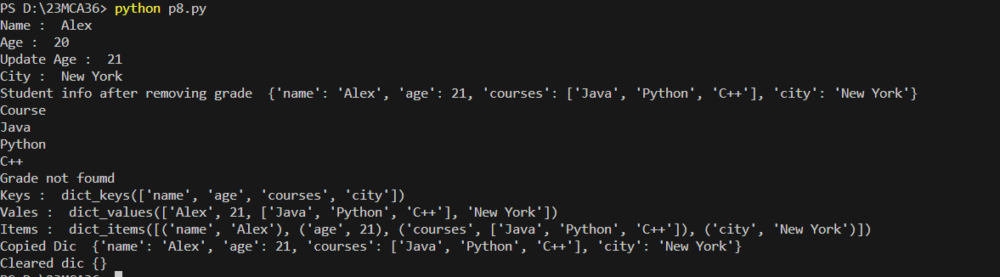

**9. Write a python program to implement functions.**

**Aim:** To create a python program to implement functions.

Description: In python, the functions are created using the def keyword. The functions can accept () and more parameter/arguments within parentheses. And functions can return values using the return statement. To execute functions we call it by its name followed by parentheses.

In this program we have demonstrated working of functions in python by creating the following functions:

➔Calculate _circle_area ()

➔Greet

➔Is_even_or_odd ()

Whose values are given as arguments during runtime. These functions calculate the area of a rectangle by area=length*width and area for circle by area of a rectangle by area=pi*radius^2 and greets the user by printf function and determines weather the number is odd or even using the if-else block statement respectively, and all the resultant values are pointed.

**Code:**

def calcualte_rectangle_area(length,width):

area=length*width

return area

def calculate_circle_area(radius):

import math

area=math.pi*radius**2

return area

def greet(name):

print(f"Hello,{name}!")

def is_even_or_odd(number):

if number%2==0:

return "Even"

else:

return "Odd"

if __name__=="__main__":

length=5

width=3

rectangle_area=calcualte_rectangle_area(length,width)

print(f"Rectangle Area:{rectangle_area}")

radius=4

circle_area=calculate_circle_area(radius)

print(f"Circle Area:{circle_area}")

name="Your Name"

greet(name)

number=7

result=is_even_or_odd(number)

print(f" {number} is {result}")

**Output:**

